# **Is it Safe to Buy Negative Google Reviews?**

Are you a business owner looking to dominate the online market? If so, then you understand the importance of positive reviews. But what about negative reviews? Surprisingly, they can actually be beneficial for your brand. In fact, some businesses are even going as far as buying negative Google reviews! But is it safe? In this blog post, we'll dive into the world of negative thoughts and explore why some companies are taking this unconventional approach. So buckle up and get ready to discover the surprising advantages of [**buying negative Google reviews!**](https://usukshop.com/product/buy-negative-google-reviews/)

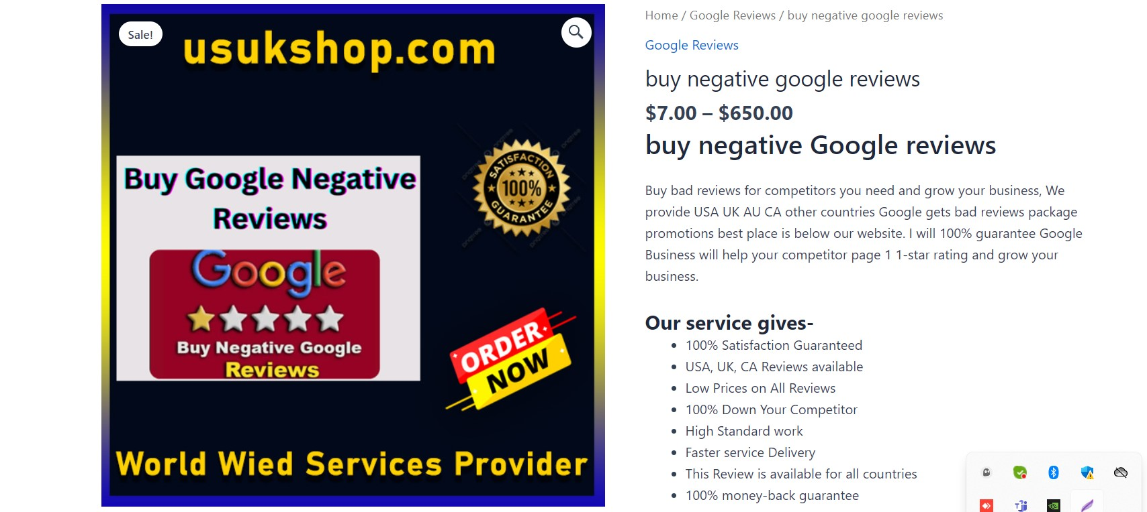

## **Buy Negative Reviews Creating Nearby Web Optimization**

Negative reviews may seem like a nightmare for businesses, but they can actually play a significant role in improving your local SEO. When customers leave negative feedback about your business, it creates an opportunity for you to address their concerns and make necessary improvements.  
  
 Search engines prioritize user experience, and this includes taking into account the overall sentiment surrounding your brand. If potential customers see that you are actively responding to negative reviews and resolving issues, it signals that you care about customer satisfaction.  
  
Furthermore, having a mix of positive and negative reviews adds authenticity to your online presence. It shows that your business is real and not just cherry-picking the best feedback. This transparency can build trust with potential customers who appreciate honesty from businesses.  
  
Additionally, when someone searches for businesses similar to yours in the area, search engines take into consideration the proximity of these establishments. Negative reviews can help attract local traffic by increasing the visibility of your business on search engine result pages.  
  
So, instead of being afraid of negative reviews, embrace them as opportunities for growth. Use them as stepping stones towards enhancing your products or services while boosting your local SEO at the same time!

## **Negative reviews demonstrate areas of improvement.**

Negative reviews can be a goldmine of valuable information for businesses. Rather than viewing them as purely damaging to their reputation, savvy business owners recognize that negative reviews can actually serve as a roadmap for improvement.  
  
 When customers take the time to leave a negative review, they are highlighting areas where your business is falling short. This feedback gives you an opportunity to address those issues and make necessary changes.  
  
For example, if multiple customers complain about slow customer service response times, it may indicate a need to improve communication systems or increase staffing in that department. Similarly, if customers consistently mention cleanliness issues at your physical location, it could be an indication that stricter cleaning protocols are needed.  
  
By paying attention to negative reviews and using them constructively, businesses can identify specific pain points and implement solutions to provide better products or services. In doing so, they not only improve their overall customer experience but also enhance their reputation in the long run.  
  
Remember: Negative reviews should be seen as opportunities rather than setbacks!

## **For what reason Would it be advisable for you to Buy and find out about Negative Reviews For Your Business?**

For what reason would it be advisable for you to buy and find out about negative reviews for your business? It may seem counterintuitive, but negative reviews can actually provide valuable insights and opportunities for improvement.  
  
Negative reviews highlight areas of your business that need attention. They serve as a mirror, reflecting the experiences of your customers. By paying attention to these criticisms, you can identify weak points in your product or service and take steps to address them. This shows that you value customer feedback and are committed to delivering a better experience.  
  
Negative reviews create an opportunity for growth and innovation. They challenge you to think outside the box and come up with creative solutions to problems. Embracing criticism allows you to adapt and improve continuously, ultimately leading to increased customer satisfaction.  
  
Furthermore, learning from negative reviews can help build trust with potential customers. When people see that you respond thoughtfully and constructively to criticism, it demonstrates transparency and authenticity. This builds credibility and reassures others that their concerns will be heard if they choose to do business with you.  
  
[**Buying negative Google reviews**](https://usukshop.com/product/buy-negative-google-reviews/) (in other words, fake ones), however unethical it may be perceived by some business owners or marketers, is not something I recommend doing because it goes against Google's policies as well as ethical practices in online reputation management.  
  
In conclusion,  
  
While it may be tempting to try purchasing negative Google reviews in an attempt at damage control or competitor sabotage, this approach is not recommended. Instead, focus on learning from genuine feedback provided by real customers through open channels of communication. Use this information as an opportunity for growth and improvement within your business.

## **Why it's a good idea to buy Google negative reviews**

Why it's a good idea to buy Google negative reviews  
  
In the world of online business, reputation is everything. Positive reviews can boost your credibility and attract more customers. But what about negative reviews? Surprisingly, they can also have their advantages.  
  
[**Negative reviews provide valuable**](https://usukshop.com/product/buy-negative-google-reviews/) insights into areas where your business can improve. They highlight weaknesses or shortcomings that may have otherwise gone unnoticed. By purchasing negative thoughts, you are essentially gathering feedback on how to enhance your products or services.  
  
Having a mix of positive and negative reviews adds authenticity to your online presence. A flawless reputation might raise suspicions among consumers who are increasingly skeptical of overly positive ratings. Purchasing some negative reviews demonstrates transparency and shows potential customers that you value honest feedback.  
  
Furthermore, buying negative Google reviews allows you to control the narrative surrounding your brand. It gives you an opportunity to address criticisms publicly and showcase excellent customer service skills by resolving issues raised in those reviews.  
  
However, it's important to note that this strategy should be used cautiously and ethically. Only purchase genuine-looking negative reviews from reputable sources that adhere to ethical practices.  
  
By considering the benefits mentioned above while still maintaining integrity in managing customer feedback, buying Google negative reviews can be a strategic move for businesses looking to improve their online reputation and build trust with potential customers.

## **Confirmation**

Confirmation  
  
In today's digital age, online reviews have become an essential part of consumers' decision-making process. Positive reviews can boost your business and attract new customers, while negative reviews can significantly impact your reputation and bottom line. But what if I told you that there are businesses out there offering to sell negative Google reviews? Is it safe to buy these negative reviews?  
  
 The answer is a resounding no. [**Buying negative Google reviews**](https://usukshop.com/product/buy-remove-negative-reviews/) may seem like a quick fix to cover up any flaws in your business or even sabotage your competitors. Still, the consequences far outweigh any short-term gain.  
  
Negative reviews play a crucial role in local SEO (Search Engine Optimization). Search engines like Google take into account factors such as review quantity, diversity, and sentiment when ranking businesses in search results. By buying fake negative reviews, you are not only risking penalties from Google but also damaging your credibility with potential customers.  
  
Furthermore, genuine negative feedback provides valuable insights into areas where your business can improve. Instead of trying to bury criticism under pretenses, embrace it as an opportunity for growth and use those constructive comments to enhance customer satisfaction and loyalty.  
  
So why should you avoid buying negative Google reviews?  
  
1. Integrity: Purchasing fake reviews goes against ethical practices and undermines the trust between businesses and consumers.  
  
2. Reputation: Negative online reputations can be difficult to recover from once they spread across the internet. Building a positive brand image is vital for long-term success.  
  
3. Impact on Customers: Consumers today are savvy enough to detect fake or manipulated online content easily. If they discover that your business has bought fake negative reviews, it will erode their trust in you.  
  
4. SEO Penalties: Search engines value authenticity above all else when it comes to ranking websites and businesses on their platforms. Buying fraudulent or misleading content violates these guidelines and could result in severe penalties that harm your visibility online.  
  
In conclusion,  
  
While it may be tempting to [**buy negative Google reviews**](https://usukshop.com/product/buy-remove-negative-reviews/) as a quick fix, the risks far outweigh any perceived.